

Our Local Labour Market
9% |  | 1 in 25 |  | 78%
Job growth in the South East Midlands over the past 5 years |  | of businesses created are based in the South East Midlands (Bedford, Luton, Milton Keynes, Northamptonshire) |  | Employment rate  overall

In the local area the labour market is growing in these sectors:
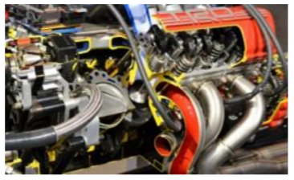 | High-Performance Technology  • Automotive vehicle and component manufacturing  • Automotive research, design and testing  • Sales and marketing head quarters  • Motorsport  • Aerospace component manufacturing and research
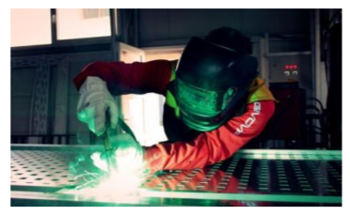 | Manufacturing & Advanced Technology  • Food and drink production  • Packaging  • Automation, mechatronics, robotics  • Additive manufacturing (3D printing)
 | Logistics & Supply Chain  • Storage and warehousing  • Road freight transport  • Rail freight terminals  • Luton Airport
 | Cultural & Creative  • Digital creative industries  • Leisure and tourism  • Performing arts  • Sport

More information on these sectors and other businesses seeking employees can be found on the SEMLEP website. http://www.semlep.com/modules/downloads/download.php?file_name=1281

What qualification levels are employers looking for?
Education is the important first step in students entering the world of work.
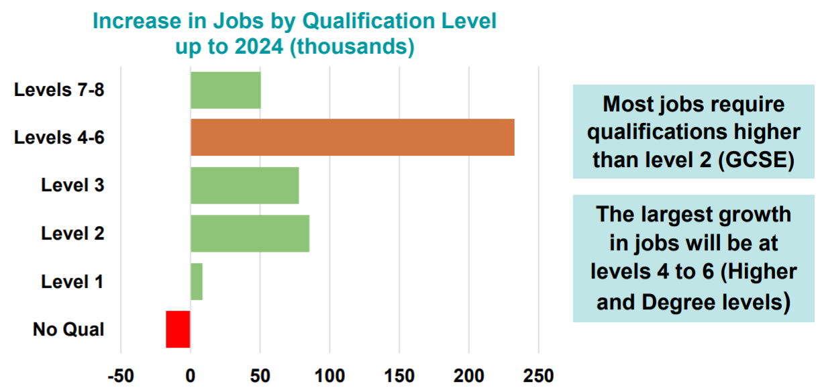

Linking Careers to Curriculum Learning (Gatsby Benchmark 4)
Abbeyfield School is committed to meeting all eight Benchmarks identified by the Gatsby Foundation.

https://youtu.be/i4rt9jAX1Hk
Working together we will be successful in achieving these and providing high quality Careers, Education, Information, Advice and Guidance to help inspire our students and enable them to make rational informed career decisions. Careers is not the responsibility of a Careers Leader and a small number of teachers, but of all staff in school.

At Abbeyfield School we aim to link careers to the curriculum using the following model:
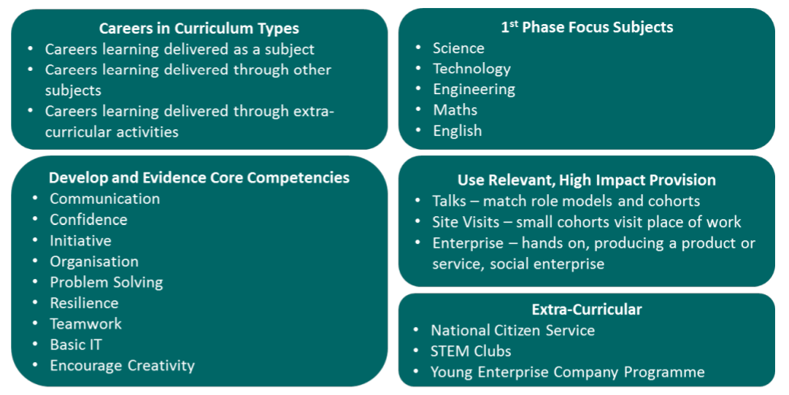

We would like all subject areas to do the following:
- adopt a strategic approach to linking curriculum learning to careers by embedding careers into lessons as part of the Ambition Curriculum in your subjects’ scheme of work - real-life contexts and examples from the world of work can make subjects more relevant, motivate students and raise attainment.
- have a prominent display that links subject learning and skill development to different careers.
- consider the needs and interests of all students and ensure that information challenges stereotyping including gender and disability
- be confident at talking about careers related to your subject matter and understand the pathways and the skills in demand from employers – there is a skills poster in every classroom.
- develop links with businesses and invite alumni and other external speakers to come into school (virtually where an actual visit is not feasible) – see below for support.
- where appropriate organise external visits to local businesses/organisations and/or use industry inspired subject content to bring industry into the curriculum - solving or addressing a real-life application can develop employability skills such as communication and team working.
- give opportunities for the core competencies to be developed and highlight to the students experiences of communication, problem solving, resilience, etc.
Subject teachers will be supported to develop and integrate careers learning opportunities into their schemes of learning through INSET sessions and faculty meetings.
Good practice and ideas for embedding careers into each subject can be found here: http://www.forum-talent-potential.org/good-practice/

There are a range of resources on the market that suggest ways of incorporating careers learning into different subject areas. A brief selection is given in the table below:
Subject | Link | Overview
General | Success at School https://successatschool.org/advice/subjects | Shows links between subjects, pathways and careers.
General | National Careers Website  https://nationalcareers.service.gov.uk/explore-careers | Database of different careers and their skills and entry requirements in each subject area.
Maths | Young Money  https://www.young-enterprise.org.uk/teachers-hub/ | Resources, support and training for financial education for delivery in PSHE and mathematics.
Science  Computing  DT  Maths | STEM Learning  https://www.stem.org.uk/resources | A number of resources for use in STEM based subjects.
Languages | Teach Learn Relax  https://teachlearnrelax.com/2018/01/28/20-tips-on-embedding-employability-into-a-language-lesson/ | 20 tips on embedding employability into a language lesson.
English  Media | Into Film  https://www.intofilm.org/resources | Film resources with activities to use in your classroom, including PowerPoint presentations with embedded clips.
Geography  Science | Practical Action  https://practicalaction.org/schools/ | Pick up and run lesson plans exploring real world issues including climate change, renewable energy, food security and disaster preparedness.
Business  Geography  DT  Science | BP Educational Resources  https://bpes.bp.com/resources/list/secondary | Lesson resources, posters, interactive resources and videos about how different subjects are used in BP’s work.

Guest Speakers
There’s no better way to engage your students in real world applications of your subject than to invite in people from industry to tell the students themselves.
You can access support in finding guest speakers through:

Our SEMLEP Enterprise Advisor - Mereway Alumni, Sunny Singh, works specifically with Abbeyfield School to:
• Share knowledge of the sector and business he works in or has had experience of in the past, to show how a subject(s) is used in the world of work
• Introduce other business people or organisations with knowledge of sectors to contribute to activity within subjects through his extensive links in the Northants Chambers of Commerce.
Please speak with our Careers Lead, Carla Dufty, to find out more.
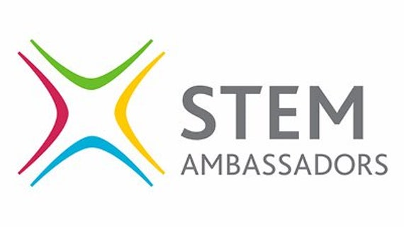
STEM Ambassadors – A database of 30,000 volunteers you can book to come into your classroom, either face-to-face or virtually, free of charge. https://www.stem.org.uk/stem-ambassadors/schools-and-colleges
STEM Ambassadors make an impact by:
• Supporting learning: help young people to understand the real-world applications of their learning
• Illuminating careers: showcase different roles and pathways into industry, raising awareness of important skills in the workplace
• Raising aspirations: help young people meet a wide range of inspiring role models, encouraging them to think about their future.


Speakers for Schools – Scheduled live talks or previously broadcasted virtual talks from a variety of high-profile professionals. https://www.speakersforschools.org/inspiration/schools-colleges/
The Speakers for Schools team connects schools with inspiring and influential people for impactful school talks, helping young people to think big and aim high – all for free.

