Information for Students
Your teachers will work with you to help you develop the skills you need for life and employment. You will receive information about placements and work opportunities and will meet people from the world of work, who could help you to acquire the skills needed to be successful in work.
The school is committed to help you to realise your potential, so you can do what you love when you leave school!
If you are wondering what you can do to improve your chances of being employable when you leave school here are some ideas:
 |  |  |  | 
Practise your computing skills | Join a club | Play a sport, train hard, join a team | Get involved with the school newsletter | Keep informed of current affairs
 |  |  |  | 
Get a paper round | Do the Duke of Edinburgh Award | Audition for shows | Join Cadets, Scouts or Guides | Learn to play a musical instrument
 | 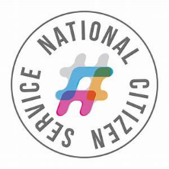 |  |  | 
Volunteer | Apply for NCS (Year 11/12 only) | Organise a charity fundraiser | Help out at a lunchtime / after school club | Set up a mini business, e.g.: cleaning cars

If you want to know how to start deciding what to aim for in your career or working life, try asking yourself these questions:
If you want more help answering these questions and deciding what you want to do, please see our careers adviser.
Look out for information about careers and employability events on posters around school, tutor group announcements, school email, and in assemblies.
You can also visit our Careers Hub at break times. The hub is a place where students can access careers books, leaflets, apprenticeship guides and prospectuses (college and university). Our resources come from quality providers including titles from the How2Become range, the National Health Service and Prospects Education.

