

Progression to Post-16 Study in Computer Science

Course Outline

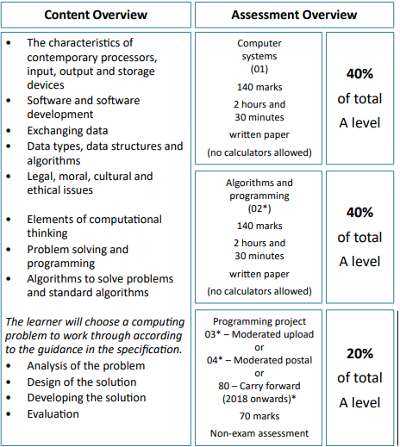

Recommended Resources:
- Craig ‘n’ Dave (Youtube Channel)
- MrBrownCS (Youtube Channel)
- Isaac Computer Science – isaaccomputerscience.org
- Ada Computer Science – adacomputerscience.org
Preparatory Activities
Purpose

20% of the total A-level is based on a programming project. You can pick what you want your project to be. Some options include: A game, data modelling, simulations or robotics

Development is not the primary purpose of the project. However, it is a big portion of the task. Should you pick game design / development having a base knowledge of Unity will make it significantly easier so that you can focus on the other areas.

We have given you this task to give you an introduction into Unity to complete in your own time over the summer so that you have a good understanding before you start the course

Task

Please go to the following link below:
https://learn.unity.com/pathway/junior-programmer/unit/player-control?version=6.0

There are a list of steps down the left-hand side for you to work through.

You can create an account to track your progress but it is more important that you install Unity and are able to show what you have done in Unity.

Follow the steps down the left-hand to install Unity and complete the 3D car game.

Submission
All tasks to be completed.
Deadline: w/c 1 September

