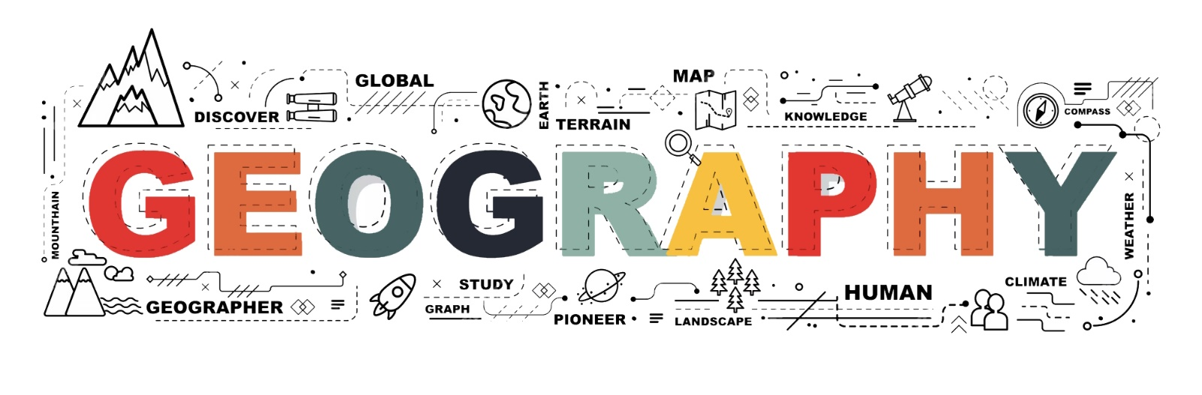

YEAR 12 TRANSITION TASK BOOKLET
2026

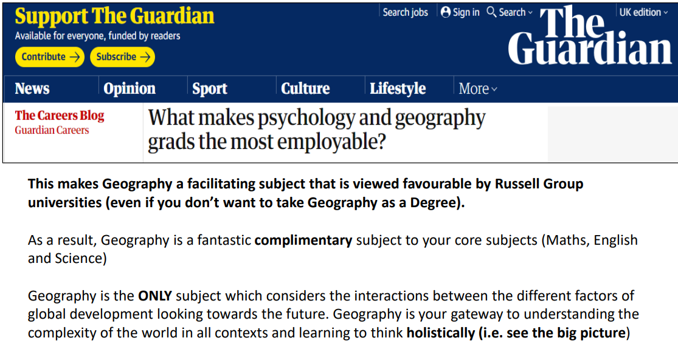
Geography Task Booklet 2026
Year 11 transition lesson 2026: independent study task:
Complete the questions below using specific facts taken from the articles, complete this by hand or on Word. In September, once completed hand your answers to your teacher, clearly marked with your name and the title: Geography Transition task:
https://www.bbc.co.uk/news/world-66525474
Open and read this article 1 carefully (Article is attached for ease of access):
- What happened to the group BRICS on 1st January 2024? Who are the new members?
- What is the aim of the group the BRICS?
- Why are the BRICS an important group on the world stage? Give a specific piece of evidence from the article to show that they are carrying out important work as an international organisation.
- Why is there is a suggestion for the BRICS to use their own currency?
https://www.bbc.co.uk/news/world-africa-66609633
Open and read this article 2 carefully (Article is attached for ease of access)::
- “China was the state pushing hardest for group expansion as a way to counter Western dominance” Read this quote from the article. Why do you think China is pushing the hardest for an expansion to the BRICS, what do you think China has to gain from extending the BRICS?
- “The growth of BRICS "will… further strengthen the force for world peace and development" Read this quote from the article. How far do you agree with this statement?
- “Then Brazilian President Luiz Inácio Lula Da Silva was a no-show to Wednesday's leadership dinner. We do not know why exactly, but he is very conscious about maintaining ties with his Western allies, and was picky about admittance” Read this quote from the article. Why do you think Brazil wants to maintain ties with the Western world?
- "No longer is it a world where the US can set all the norms, or drive all the institutions” Read this quote from the article. Why do you think historically the US has been the most powerful nation? Why does the US set all the norms?
- BRICS countries have a combined population of more than 3.2 billion people, making up about 40% of the world's roughly 8 billion people. Read this quote, not taken from the article. To what extent do you think this is an important point to consider- do you think that population size is an important factor in global power? Explain your answer.

Article 1

BRICS: What is the group and which countries have joined?
1 February 2024
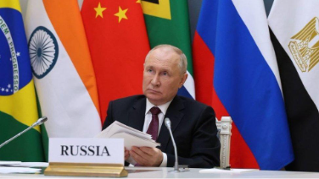
Saudi Arabia has joined BRICS, the alliance of major developing countries, along with four other nations.
The Saudi membership was due to start on 1 January, but there was a delay before it was confirmed.
The BRICS group wants emerging economies to have more influence in international politics.

What does BRICS mean and who are the new members?
In 2006, Brazil, Russia, India and China created the "Bric" group. South Africa joined in 2010, making it "BRICS".
The group was designed to bring together the world's most important developing countries, to challenge the political and economic power of the wealthier nations of North America and Western Europe.
Egypt, Ethiopia, Iran, Saudi Arabia and the United Arab Emirates (UAE) were invited to become members with effect from 1 January 2024.
A Saudi Arabian government minister said in mid January it had not joined, external.
But South Africa's government since confirmed its membership status, external.
Argentina was also invited to join, but President Javier Milei pulled out in December 2023, shortly after taking office.
The group sets priorities and makes decisions at an annual summit. Members take it in turns to serve as president for a year.
The name for the expanded group has not yet been announced, but may be "BRICS +".

Why does BRICS matter?
BRICS countries include major world powers, such as China and Russia, and countries which are influential on their continent, such as South Africa and Brazil.
The expanded group has a combined population of about 3.5 billion, external, or 45% of the world's inhabitants.
Combined, members' economies are worth more than $28.5tn, external - about 28% of the global economy.

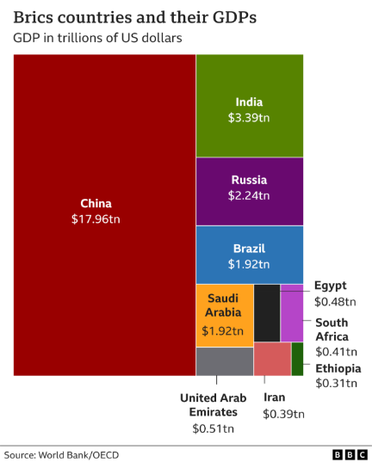
With Iran, Saudi Arabia and UAE as members, BRICS countries produce about 44% of the world's crude oil, external.
However, the group argues that Western nations dominate important global bodies such as the International Monetary Fund and the World Bank, which lend money to governments.
It wants to see a "greater voice and representation", external for emerging economies.
In 2014, the BRICS nations set up the New Development Bank to lend money to boost infrastructure.
By the end of 2022, it had provided nearly $32bn to emerging nations, external for new roads, bridges, railways and water supply projects.
This is China's main aim for BRICS, according to Prof Padraig Carmody from Trinity College Dublin.
"Through BRICS, China is trying to grow its power and influence - especially in Africa," he says. "It wants to be be the leading voice for the global south."
The other major world power in the group has a different purpose:
"Russia sees [BRICS] as part of its fight against the West, helping it to overcome the sanctions imposed after the invasion of Ukraine," says Creon Butler of the London-based think tank Chatham House.
Iran's membership could increase the anti-Western nature of BRICS, he adds.

Will a BRICS currency replace the dollar?
Nations often use the US dollar to trade between themselves.
Leading politicians in Brazil and Russia have suggested creating a BRICS currency, to reduce the dollar's dominance. However, this was not discussed at the group's 2023 summit.
It would be impractical for BRICS nations to create a common currency because their economies are so different, says Professor Carmody.
However, he says it is possible that "they may consider in the future creating some new currency to be used for international trade payments, or a cryptocurrency for international trade".

Is BRICS a rival to the G20?
The G20 group was set up in 1999 for developed and developing nations to discuss global issues.
However, the BRICS group also contains many of the countries which are in the G20.
In future, they may work in tandem, says Dr Irene Mia from the International Institute for Strategic Studies think tank.
"Together, they might push for more money for developing nations to tackle climate change," she says.

How will Russia use its 2024 BRICS presidency?
Russia will host the 20024 BRICS summit in Kazan in October.
President Vladimir Putin has said he wants to, external:
- increase the role of BRICS in the international financial system
- develop cooperation between banks, and expand the use of BRICS currencies
- promote collaboration between tax and customs authorities
"With BRICS, Russia will want to show the West that it still has friends and allies in the rest of the world, despite its invasion of Ukraine," says Dr Mia.

Article 2

BRICS summit: Is a new bloc emerging to rival US leadership?
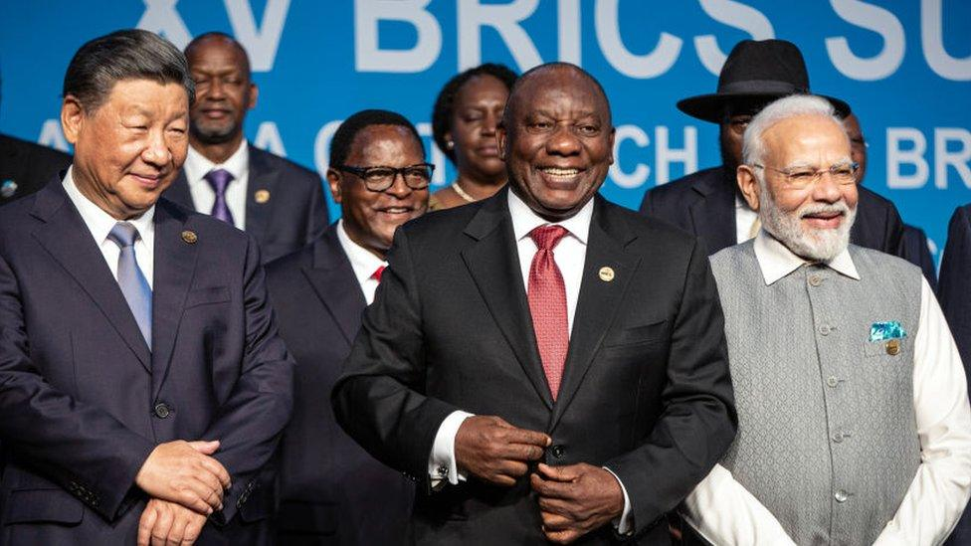
The announced expansion of the five-nation BRICS club of emerging economies was described as "historic" by Chinese President Xi Jinping, but it is still not clear how far the countries' common interests stretch.
The growth of BRICS "will… further strengthen the force for world peace and development" the president said while addressing the leaders gathered at a conference centre in South Africa's commercial hub, Johannesburg.
The BRICS countries - Brazil, Russia, India, China and South Africa - are often seen as a counterweight to the Western-led world.
The six new countries - Argentina, Egypt, Iran, Ethiopia, Saudi Arabia and the United Arab Emirates - are set to join in January.
China was the state pushing hardest for group expansion as a way to counter Western dominance.
Steve Tsang, director of London's Soas China Institute, says though the BRICS members do not have much in common on the surface, President Xi was trying to show his fellow bloc members that they all want a similar future: none of them want to live in a Western-dominated world.
"What the Chinese are offering is an alternative world order for which autocrats can feel safe and secure in their own countries," says Prof Tsang.
"They can find an alternative direction of development without having to accept the conditionalities imposed by the democratic Americans and European powers."

'Building partnership'
The host, South African President Cyril Ramaphosa, beamed as he made the announcement about the new joiners.
"We value the interest of other countries in building a partnership with BRICS," Mr Ramaphosa said.
He went on to say that more countries will join in the future after the core nations agree on criteria for membership.
But there were divisions this time on how many countries should be allowed to join and how quickly.
A leaders' press conference was scheduled for Wednesday after rumours were swirling about five countries being added to the bloc, but it was cancelled at the last minute.
Then Brazilian President Luiz Inácio Lula Da Silva was a no-show to Wednesday's leadership dinner.
We do not know why exactly, but he is very conscious about maintaining ties with his Western allies, and was picky about admittance.
Then late Wednesday night, journalists received an advisory for an early morning press conference, just for it to be delayed again by two hours. These were signs that discussions were under way until the very last minute, as there was a surprise sixth country added.
At the press event, the leaders from each country were then able to give individual reactions to the news.
Russian President Vladmir Putin joined by video link from Russia because of the danger of being arrested over alleged war crimes in Ukraine.
In his remarks, he once again took aim at Western powers, saying their "neo-liberalism" posed a threat to both traditional values in developing countries and to the emergence of a multi-polar world where no one country or bloc dominated.
Without naming names, it was clear who President Putin was speaking about: the United States.
And though the super-power was not at the meeting, the US was talked about, or referenced, quite a bit.
On Tuesday, White House National Security Advisor Jake Sullivan attempted to play down the bloc's expansion plans.
He said that due to BRICS countries' divergence of views on critical issues, he did not see it as "evolving into some kind of geo-political rival to the United States or anyone else".
And he may be right.

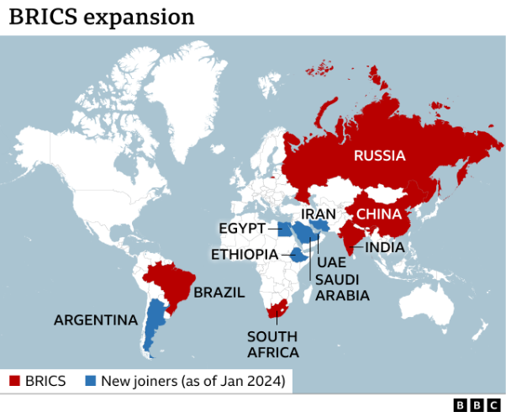
Of the six new members, none are seen as anti-American states, according to Sarang Shidore, director of the Global South programme at the Quincy Institute in Washington.
"I think the message is that this is a diverse set of countries, none of them are close US allies, formal allies, two or three of them will be US opponents. But more broadly, this is not a group of anti-American states," he told the BBC.
'US can't set all norms'
Nevertheless, the BRICS expansion does represent a shift.
"No longer is it a world where the US can set all the norms, or drive all the institutions. There's no question about that. But a replacement? No, I would say much more of a complementarity than a replacement that is on the horizon," Mr Shidore added.
So for a group that says they all value and respect each other's opinions, maybe no-one won or lost. It really was just a diplomatic gathering with some give and take.
Mr Putin was not arrested, and thanks to modern day technology, Russia was still represented.
China got its big plan for membership expansion.
Brazil's push for a common currency is being taken seriously.
India was seen as trying to balance its friendship with America.
And South Africa, hosted a successful meeting with no public fallouts.

Geography Transition task
Name:

________________________________________________________________________________________________________________________________________________________________________________________________________________________________________________________________________________________________________________________________________________________________________________________________________________________________________________________________________________________________________________________________________________________________________________________________________________________________________________________________________________________________________________________________________________________________________________________________________________________________________________________________________________________________________________________________________________________________________________________________________________________________________________________________________________________________________________________________________________________________________________________________________________________________________________________________________________________________________________________________________________________________________________________________________________________________________________________________________________________________________________________________________________________________________________________________________________________________________________________________________________________________________________________________________________________________________________________________________________________________________________________________________________________________________________________________________________________________________________________________________________________________________________________________________________________________________________________________________________________________________________________________________________________________________________________________________________________________________________________________________________________________________________________________________________________________________________________________________________________________________________________________________________________________________________________________________________________________________________________________________________________________________________________________________________________________________________________________________________________________________________________________________________________________________________________________________________________________________________________________________________________________________________________________________________________________________________________________________________________________________________________________________________________________________________________________________________________________________________________________________________________________________________________________________________________________________________________________________________________________________________________________________________________________________________________________________________________________________________________________________________________________________________________________________________________________________________________________________________________________________________________________________________________________________________________________________________________________________________________________________________________________________________________________________________________________________________________________________________________________________________________________________________________________________________________________________________________________________________________________________________________________________________________________________________________________________________________________________________________________________________________________________________________________________________________________________________________________________________________________________________________________________________________________________________________________________________________________________________________________________________________________________________________________________________________________________________________________________________________________________________________________________________________________________________________________________________________________________________________________________________________________________________________________________________________________________________________________________________________________________________________________________________________________________________________________________________________________________________________________________________________________________________________________________________________________________________________________________________________________________________________________________________________________________________________________________________________________________________________________________________________________________________________________________________________________________________________________________________________________________________________________________________________________________________________________________________________________________________________________________________________________________________________________________________________________________________________________________________________________________________________________________________________________________________________________________________________________________________________________________________________________________________________________________________________________________________________________________________________________________________________________________________________________________________________________________________________________________________________________________________________________________________________________________________________________________________________________________________________________________________________________________________________________________________________________________________________________________________________________________________________________________________________________________________________________________________________________________________________________________________________________________________________________________________________________________________________________________________________________________________________________________________________________________________________________________________________________________________________________________________________________________________________________________________________________________________________________________________________________________________________________________________________________________________________________________________________________________________________________________________________________________________________________________________________________________________________________________________________________________________________________________________________________________________________________________________________________________________________________________________________________________________________________________________________________________________________________________________________________________________________________________________________________________________________________________________________________________________________________________________________________________________________________________________________________________________________________________________________________________________________________________________________________________________________________________________________________________________________________________________________________________________________________________________________________________________________________________________________________________________________________________________________________________________________________________________________________________________________________________________________________________________________________________________________________________________________________________________________________________________________________________________________________________________________________________________________________________________________________________________________________________________________________________________________________________________________________________________________________________________________________________________________________________________________________________________________________________________________________________________________________________________________________________________________________________________________________________________________________________________________________________________________________________________________________________________________________________________________________________________________________________________________________________________________________________________________________________________________________________________________________________________________________________________________________________________________________________________________________________________________________________________________________________________________________________________________________________________________________________________________________________________________________________________________________________________________________________________________________________________________________________________________________________________________________________________________________________________________________________________________________________________________________________________________________________________________________________________________________________________________________________________________________________________________________________________________________________________________________________________________________________________________________________________________________________________________________________________________________________________________________________________________________________________________________________________________________________________________________________________________________________________________________________________________________________________________________________________________________________________________________________________________________________________________________________________________________________________________________________________________________________________________________________________________________________________________________________________________________________________________________________________________________________________________________________________________________________________________________________________________________________________________________________________________________________________________________________________________________________________________________________________________________________________________________________________________________________________________________________________________________________________________________________________________________________________________________________________________________________________________________________________________________________________________________________________________________________________________________________________________________________________________________________________________________________________________________________________________________________________________________________________________________________________________________________________________________________________________________________________________________________________________________________________________________________________________________________________________________________________________________________________________________________________________________________________________________________________________________________________________________________________________________________________________________________________________________________________________________________________________________________________________________________________________________________________________________________________________________________________________________________________________________________________________________________________________________________________________________________________________________________________________________________________________________________________________________________________________________________________________________________________________________________________________________________________________________________________________________________________________________________________________________________________________________________________________________________________________________________________________________________________________________________________________________________________________________________________________________________________________________________________________________________________________________________________________________________________________________________________________________________________________________________________________________________________________________________________________________________________________________________________________________________________________________________________________________________________________________________________________________________________________________________________________________________________________________________________________________________________________________________________________________________________________________________________________________________________________________________________________________________________________________________________________________________________________________________________________________________________________________________________________________________________________________________________________________________________________________________________________________________________________________________________________________________________________________________________________________________________________________________________________________________________________________________________________________________________________________________________________________________________________________________________________________________________________________________________________________________________________________________________________________________________________________________________________________________________________________________________________________________________________________________________________________________________________________________________________________________________________________________________________________________________________________________________________________________________________________________________________________________________________________________________________________________________________________________________________________________________________________________________________________________________________________________________________________________________________________________________________________________________________________________________________________________________________________________________________________________________________________________________________________________________________________________________________________________________________________________________________________________________________________________________________________________________________________________________________________________________________________________________________________________________________________________________________________________________________________________________________________________________________________________________________________________________________________________________________________________________________________________________________________________________________________________________________________________________________________________________________________________________________________________________________________________________________________________________________________________________________________________________________________________________________________________________________________________________________________________________________________________________________________________________________________________________________________________________________________________________________________________________________________________________________________________________________________________________________________________________________________________________________________________________________________________________________________________________________________________________________________________________________________________________________________________________________________________________________________________________________________________________________________________________________________________________________________________________________________________________________________________________________________________________________________________________________________________________________________________________________________________________________________________________________________________________________________________________________________________________________________________________________________________________________________________________________________________________________________________________________________________________________________________________________________________________________________________________________________________________________________________________________________________________________________________________________________________________________________________________________________________________________________________________________________________________________________________________________________________________________________________________________________________________________________________________________________________________________________________________________________________________________________________________________________________________________________________________________________________________________________________________________________________________________________________________________________________________________________________________________________________________________________________________________________________________________________________________________________________________________________________________________________________________________________________________________________________________________________________________________________________________________________________________________________________________________________________________________________________________________________________________________________________________________________________________________________________________________________________________________________________________________________________________________________________________________________________________________________________________________________________________________________________________________________________________________________________________________________________________________________________________________________________________________________________________________________________________________________________________________________________________________________________________________________________________________________________________________________________________________________________________________________________________________________________________________________________________________________________________________________________________________________________________________________________________________________________________________________________________________________________________________________________________________________________________________________________________________________________________________________________________________________________________________________________________________________________________________________________________________________________________________________________________________________________________________________________________________________________________________________________________________________________________________________________________________________________________________________________________________________________________________________________________________________________________________________________________________________________________________________________________________________________________________________________________________________________________________________________________________________________________________________________________________________________________________________________________________________________________________________________________________________________________________________________________________________________________________________________________________________________________________________________________________________________________________________________________________________________________________________________________________________________________________________________________________________________________________________________________________________________________________________________________________________________________________________________________________________________________________________________________________________________________________________________________________________________________________________________________________________________________________________________________________________________________________________________________________________________________________________________________________________________________________________________________________________________________________________________________________________________________________________________________________________________________________________________________________________________________________________________

